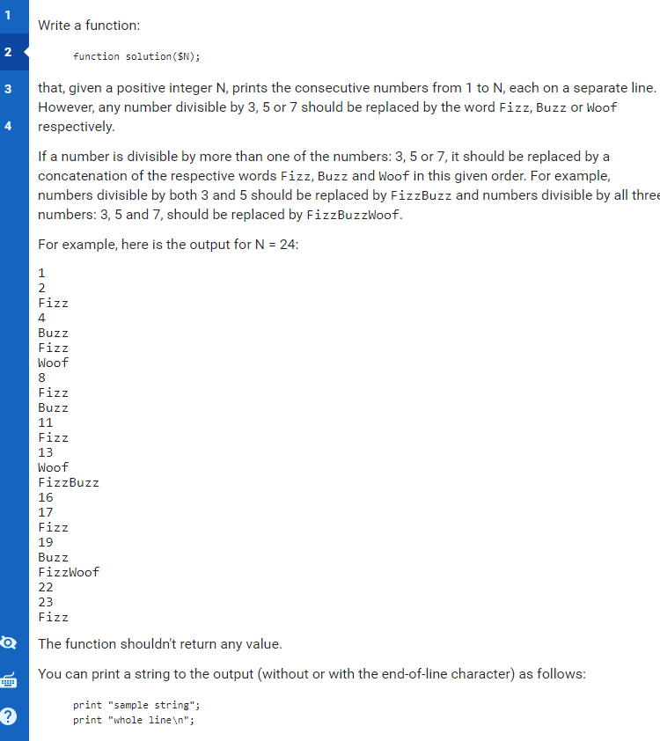 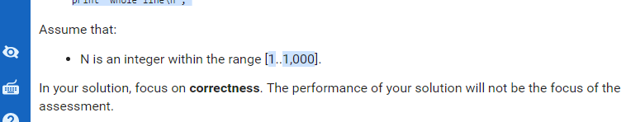 // you can write to stderr for debugging purposes, e.g.

// fprintf(STDERR, "this is a debug message\n");

function solution($N) {

for ($i = 1; $i <= $N; $i++) {

$x = 3;

$y = 5;

$z = 7;

$resultX = fmod($i, $x);

$resultY = fmod($i, $y);

$resultZ = fmod($i, $z);

$indX = "";

$indY = "";

$indZ = "";

if ($resultX == 0) {

$indX = "Fizz";

}

if ($resultY == 0) {

$indY = "Buzz";

}

if ($resultZ == 0) {

$indZ = "Woof";

}

if ($indX || $indY || $indZ != "") {

echo $indX.$indY.$indZ."\n";

}else

echo $i."\n";

}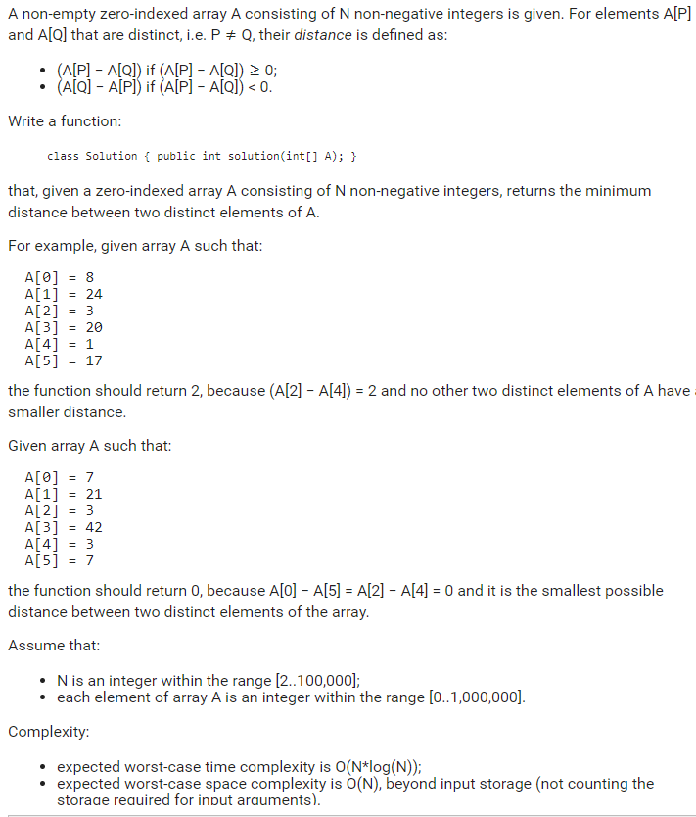

// you can also use imports, for example:

// import java.util.\*;

// you can write to stdout for debugging purposes, e.g.

// System.out.println("this is a debug message");

class Solution {

public int solution(int[] A) {

// write your code in Java SE 8

}

}

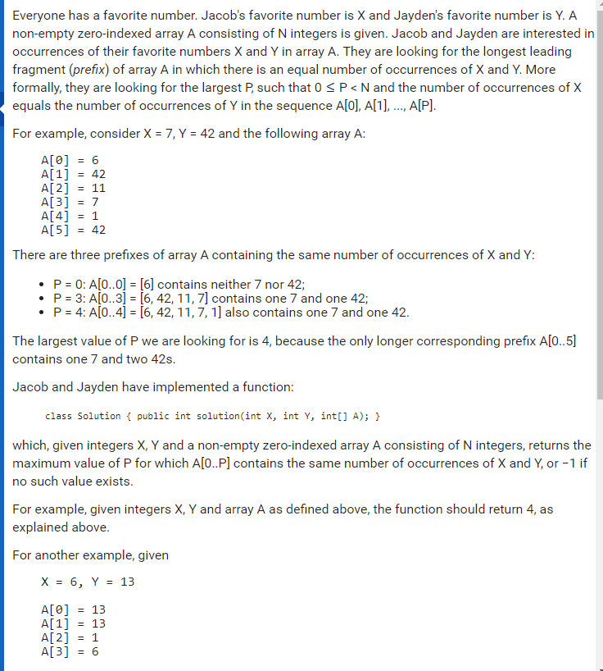

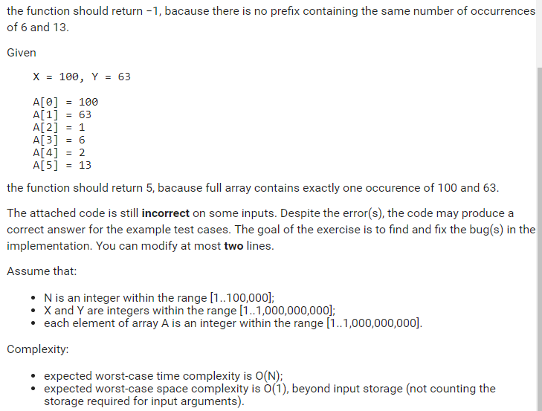

import java.util.\*;

class Solution {

int solution(int X, int Y, int[] A) {

int N = A.length;

int result = -1;

int nX = 0;

int nY = 0;

for (int i = 0; i < N; i++) {

if (A[i] == X)

nX += 1;

else if (A[i] == Y)

nY += 1;

if (nX == nY)

result = i;

}

return result;

}

}